Ordering Components

SensMat Particle Sensor

Hardware Documentation

PCB

**KiCad schematics and PCB layout files:** *Electronic/Sensor_Node_LoRa_SPS30*

The PCB was ordered from [multi-cb](https://www.multi-circuit-boards.eu/index.html) with the following options:

• 2 Layers

• Marking print only on TOP layer

• Surface finish: Chemical gold (golden pads, to apply a uniform solder paste layer)

• SMD-Stencil for TOP layer

Components

**Bill of material:** *Electronic/Sensor_Node_LoRa_SPS30/BOM.xlsx*

All components needed to assembly a sensor node are listed in this file, which can be directly imported on Digikey to create a shopping basket with these components.

The battery pack can be ordered from RS Components or Conrad.

Preparing Enclosure

For the user interface components and the air inlets and outlets for the sensors, several cutouts and holes need to be milled/drilled into the enclosure.

**2D drawing of cutouts:** *Mechanical/Particle_Sensor/Cutouts_2D_drawings/SensMat_Particle_Sensor_Case_Drawing.pdf*

The 3D model and the drawings can be copied and edited with the CAD software onshape under the following link: <https://cad.onshape.com/documents/94d0b9a1ed58ea264eb00316/w/a0f4a54bc0e628687386d942/e/6e763f8990ee83a23a9b510b>

3D Printing Holders

The holders were designed with onshape and can be edited under the following link: <https://cad.onshape.com/documents/67b8869cf1df192a304d1fb2/w/1d02d8d6dcd2133aea02d14b/e/42b0f32d318356347c3edb8e>

**Files for SolidWorks, STL files and 3D printing files for the Formlabs printers:** *Mechanical/Particle_Sensor/Holders/*

**3D model of the assembled sensor node:** [*https://cad.onshape.com/documents/1485024658cf22af04ef01d8/w/776367c9130d97246aa12ca5/e/32b621c0373ff8d4518f53b5*](https://cad.onshape.com/documents/1485024658cf22af04ef01d8/w/776367c9130d97246aa12ca5/e/32b621c0373ff8d4518f53b5)

The holders are printed on the [Formlabs Form 3](https://formlabs.com/de/3d-printers/form-3/) printer with black V4 resin.

After printing the holder parts, it is important to place them in the same orientation as shown in Figure 1 in the isopropyl alcohol bath to clean and the dryer to cure the parts. Otherwise, the parts may not fit into the housing as additional resin may cure on the parts.

Manufacturing a Sensor Node

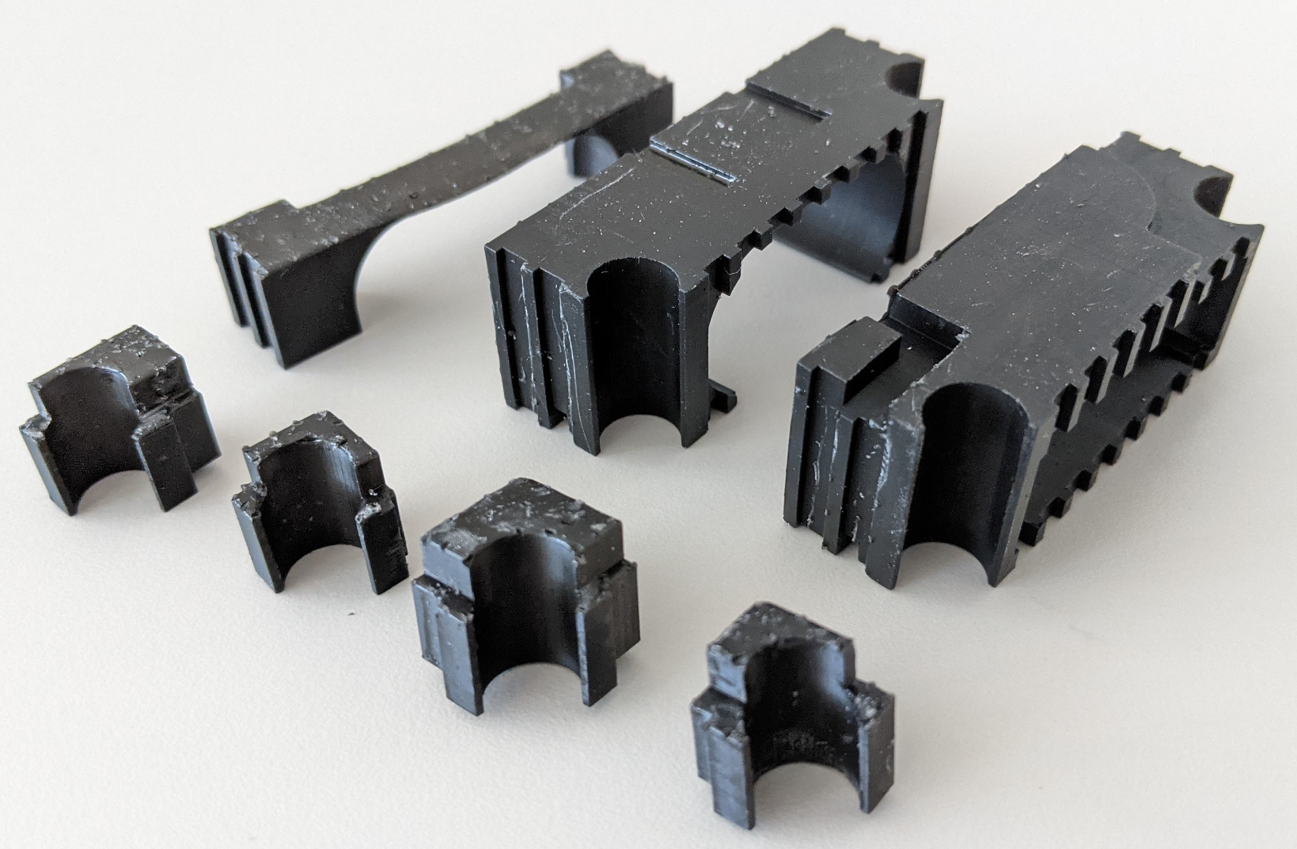

Figure 1: Holder parts, oriented as they should be placed for cleaning and curing.

Soldering SMD Component

After applying the solder paste with the stencil on the TOP layer, all SMD components are placed either with a pick-and-place machine or by hand. Afterward, the PCB is put in a reflow oven and then, the PCB looks as depicted in Figure 2.

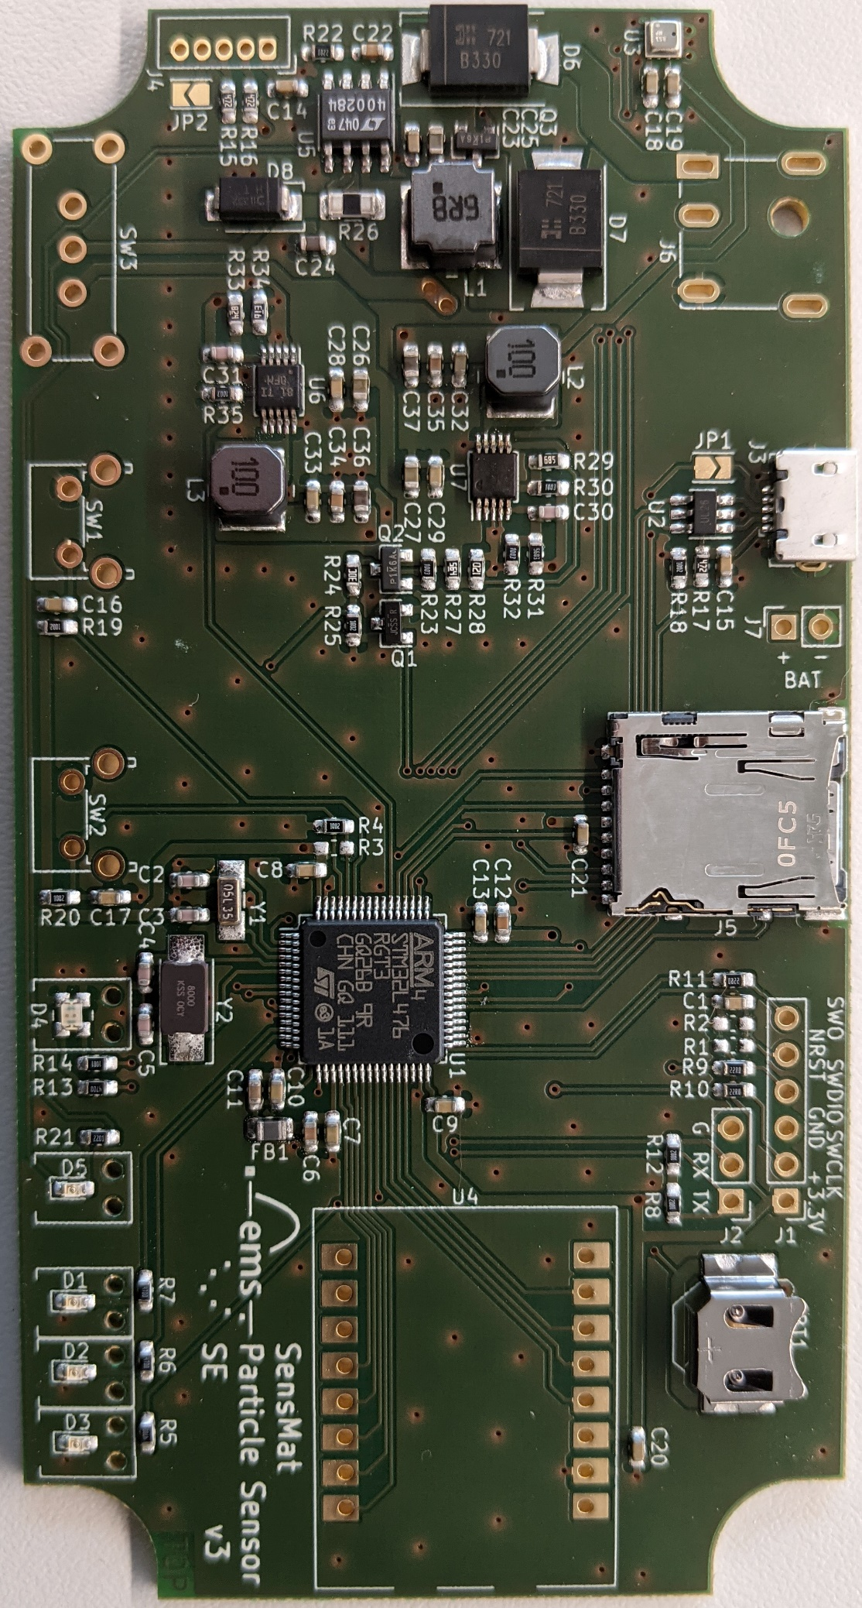

Figure 2: Circuit board with all SMD components mounted.

Manually Soldering Components

All wired components are soldered manually onto the board using a soldering iron. The two mounting lugs of the micro-USB connector are also soldered manually. The pins from the LAMBDA62-8D LoRa module protruding at the bottom side of the PCB are cut after soldering. A U.FL connector is soldered onto the LoRa module for the antenna cable to be connected.

The 10k-thermistor and the battery connector are soldered onto the bottom side of the circuit board.

Figure 3: Top side of the circuit board with the wired components marked red.

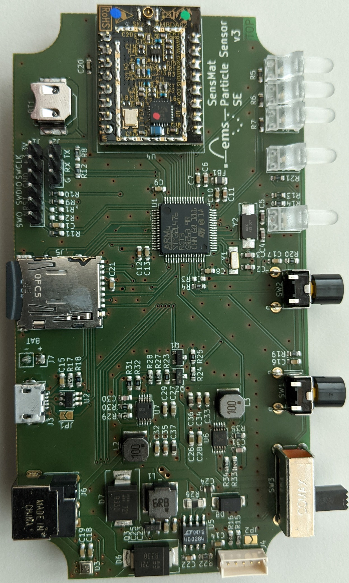

Figure 4: Bottom side of the circuit board with the 10k-thermistor and the battery connector.

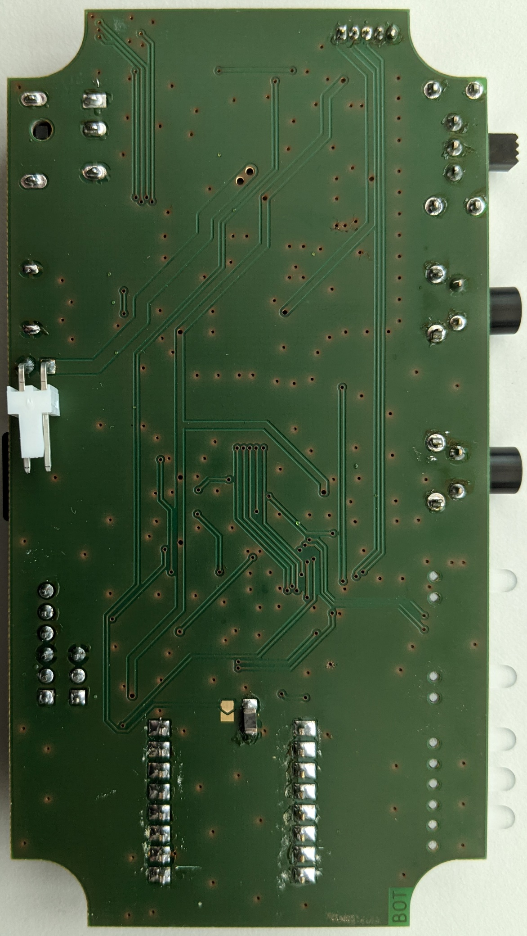

Assemble Sensor Node

Before putting the components into the enclosure, the following steps are needed:

* Press the caps onto the push buttons.

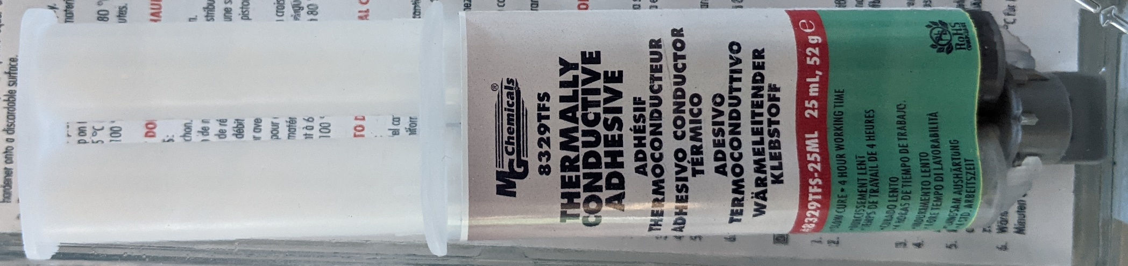

Figure 5: Conductive glue for heat sinks.

* Glue the heat sinks as shown in Figure 6 onto the diodes and the inductor with the conductive glue depicted in Figure 5. The glue should be cured at 60°C. It also hardens if the heat sinks are glued onto to parts and subsequentially the battery is charged, which will heat up the parts.

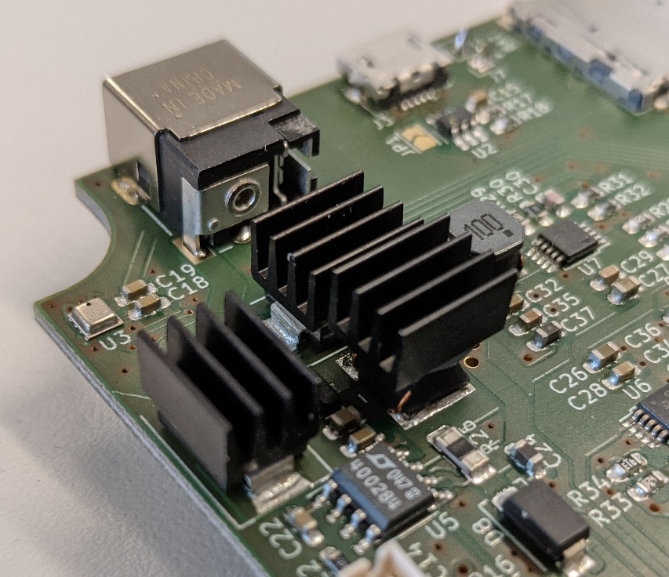

Figure 6: Heat sinks glued onto the diodes and the inductor.

* Press in the light pipes using a wrench until they lie flat on the PCB’s surface.
* Insert the coin cell battery.

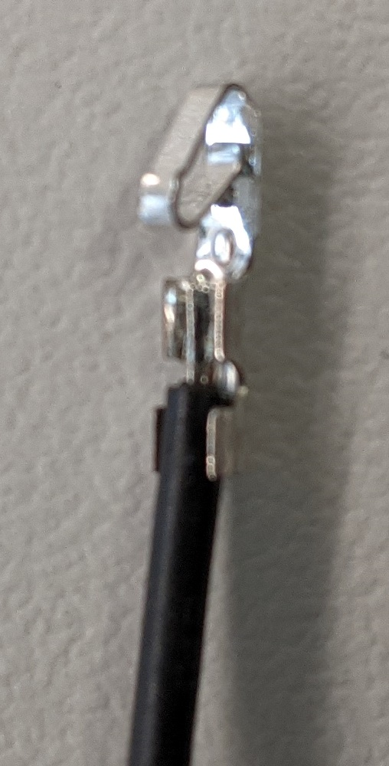

Figure 7: Crimp contacts on battery wires

* Crimp the contacts onto the wires (see Figure 7) of the battery pack and then put then into the connector housing as shown in Figure 8.

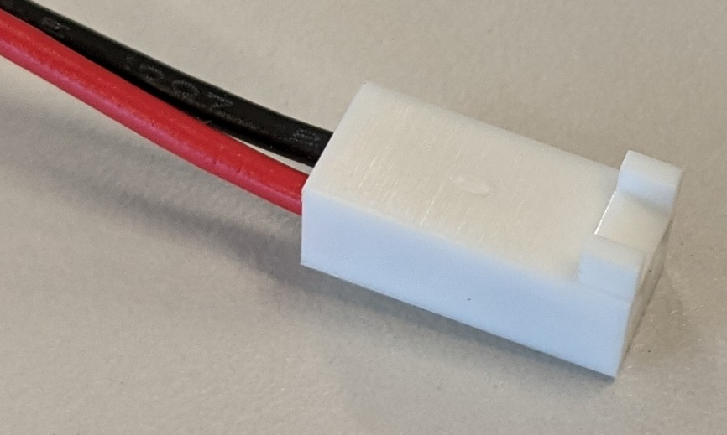

Figure 8: Crimped contacts inserted into battery connector housing

Afterward, the components can be inserted into the housing in the following order:

1. Insert middle part into housing.
2. Connect cable to particle sensor and put the sensor into holder part.

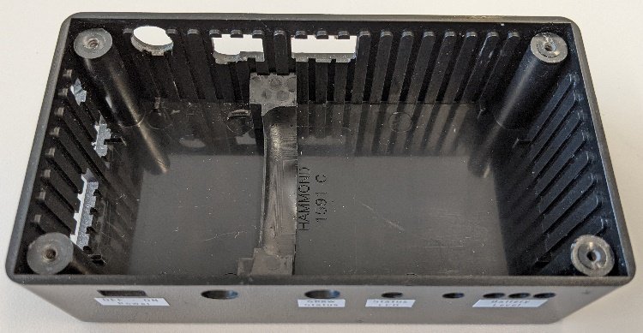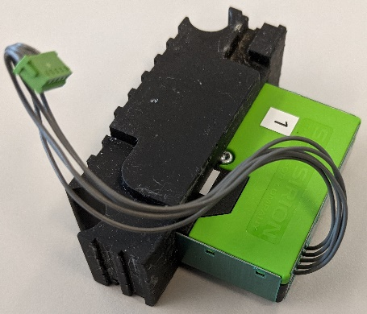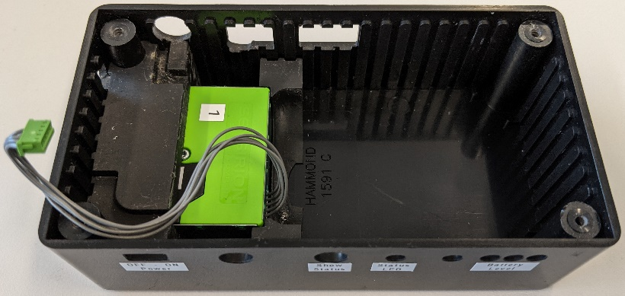

1. Insert particle sensor and holder into housing.
2. Put battery pack in the shown orientation into the holder part.
3. Insert battery pack and holder into housing
4. Bend the particle sensor cable as shown.

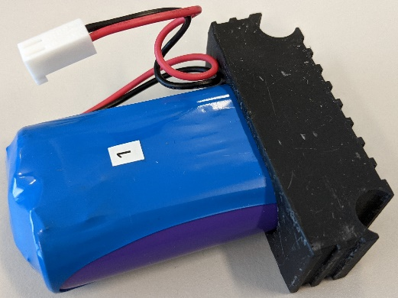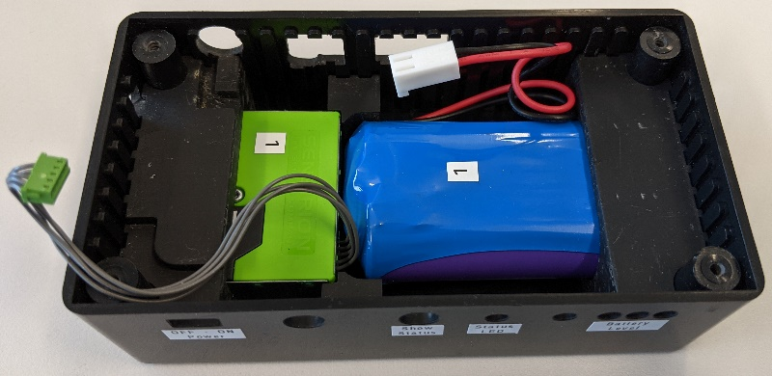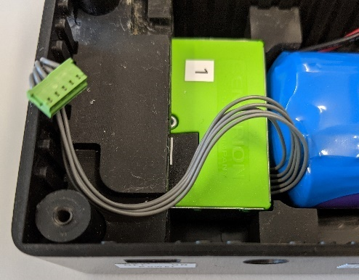

1. Connect the battery pack to the circuit board and put the wires in the empty space besides the battery.
2. Insert the PCB and connect the cable from the particle sensor to the PCB.
3. Insert the four remaining holder parts on the four edges to fix the PCB

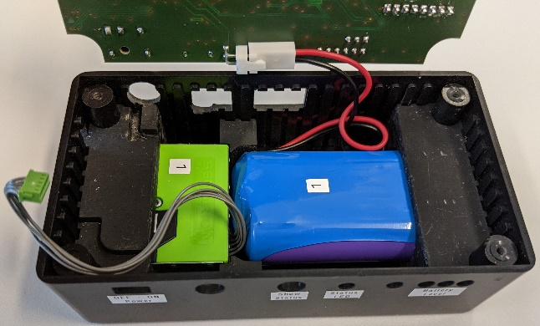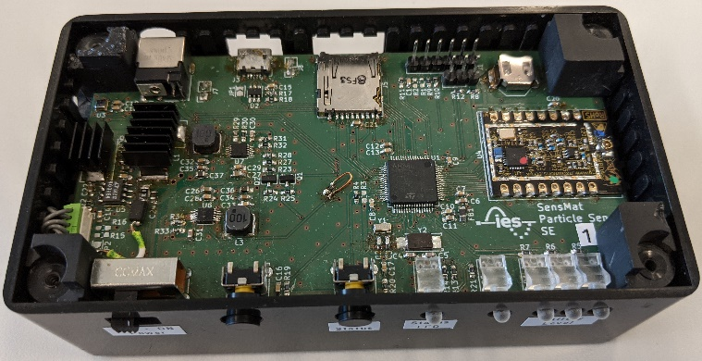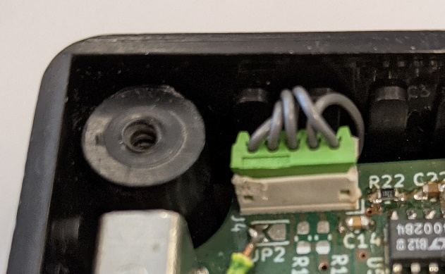

1. Stick the adhesive antenna onto the lid.
2. Connect the antenna to the LoRa module on the PCB.
3. Put the lid on the housing and fix it with four screws.

